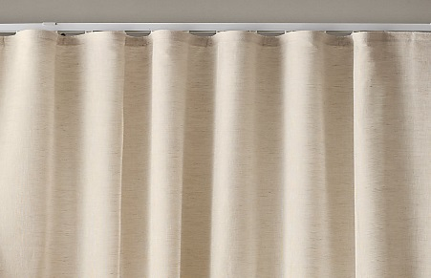 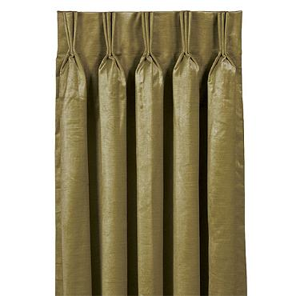

RIPPLEFOLD PANELS FRENCH PLEAT

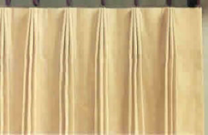 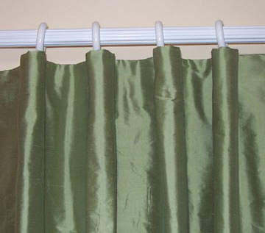

EURO PLEAT CARTRIDGE PLEAT

 [](http://www.google.com/url?sa=i&rct=j&q=&esrc=s&source=images&cd=&cad=rja&uact=8&ved=0ahUKEwj83Lrgxv_WAhVqw1QKHaBlCM0QjRwIBw&url=http://www.funtastiknorthcarolina.com/charm-pinch-pleat-drapes/&psig=AOvVaw0ssmCjlEYkay8LO7lVogUX&ust=1508600972309090)

2 FINGER EURO PLEAT 3 FINGER/PRONG PINCH PLEAT

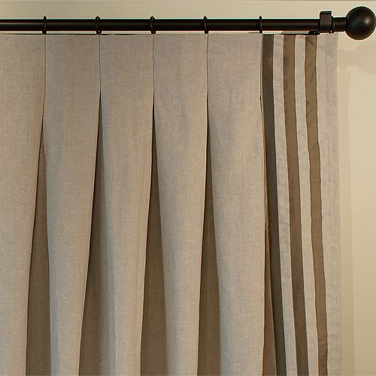

[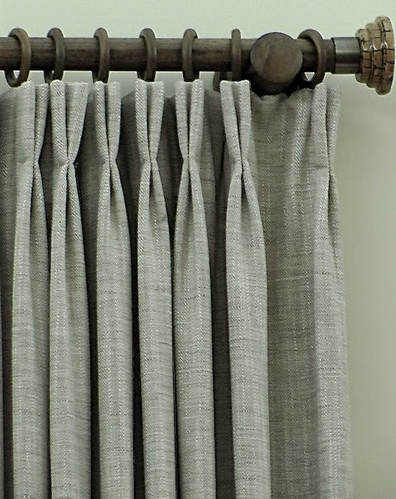](http://www.google.com/url?sa=i&rct=j&q=&esrc=s&source=images&cd=&cad=rja&uact=8&ved=0ahUKEwiLgqaIx__WAhVKi1QKHSiGD_UQjRwIBw&url=http://fioritointeriordesign.blogspot.com/2015/06/ten-basic-drapery-pleats.html&psig=AOvVaw0plNPGvrHgkNInpQyFbd-G&ust=1508601056432311)  
2 FINGER/PRONG PINCH PLEAT REVERSE PLEAT